**Experiment-2**

**Title:** Jenkins Job Chain

**Aim:** Create Jenkins job chain for following jobs:

1. BuildJob
2. TestJob
3. DeployJob

Each job will print a console message on command prompt.

**Creation of jobs**

**Creating BuildJob**

1. Click on **New Item** on left side of **Jenkins Dashboard**

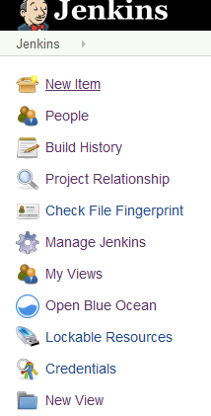

1. Enter Project name as **BuildJob** and select **Freestyle** project as project type. Click on OK.

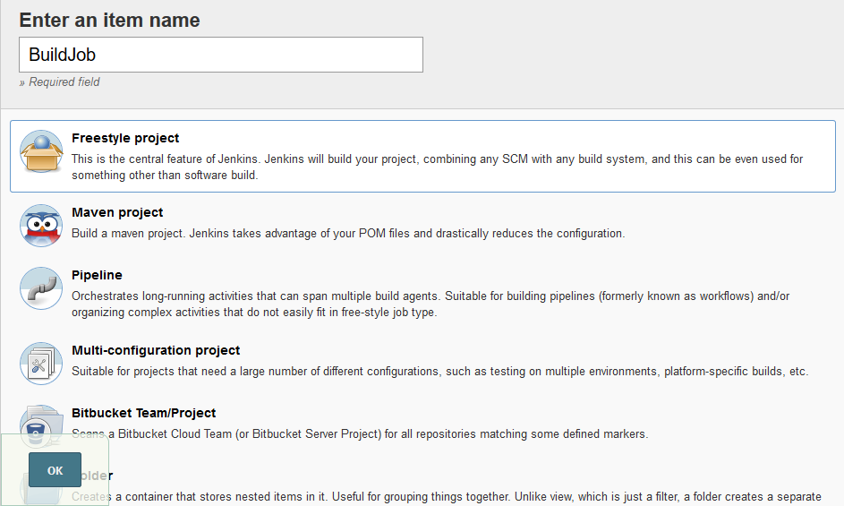

1. In **Configure Job** -> **General** tab => Give description of the job.

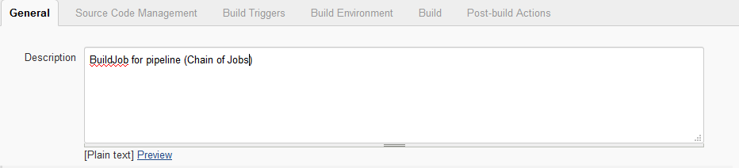

1. In **Configure Job** -> **Build** tab => Add **Execute Windows Batch commands.**

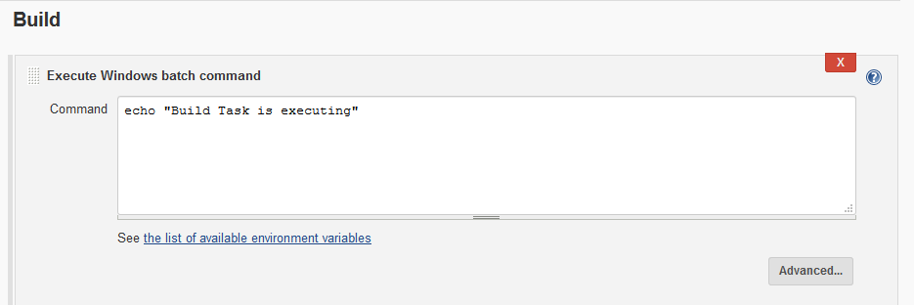

**Creating TestJob**

1. Click on **New Item** on left side of **Jenkins Dashboard.**

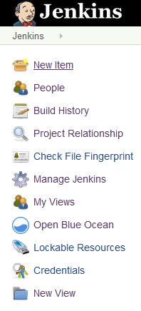

1. Enter Project name as **TestJob** and select **Freestyle** project as project type. Click on OK.

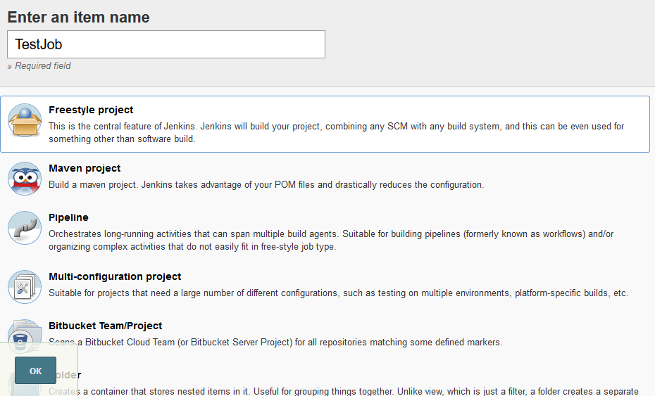

1. In **Configure Job** -> **General** tab => Give description of the job.

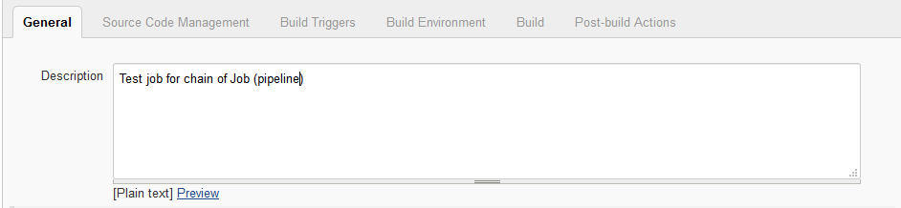

1. In **Configure Job** -> **Build** tab => Add **Execute Windows Batch commands.**

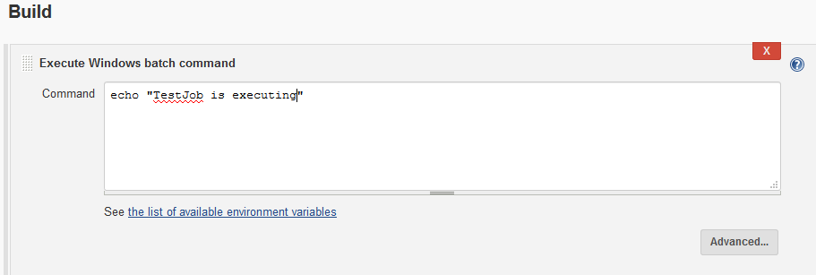

1. In **Configure Job** -> **Build Triggers** tab => Add **after other projects are build** => Specify **BuildJob**

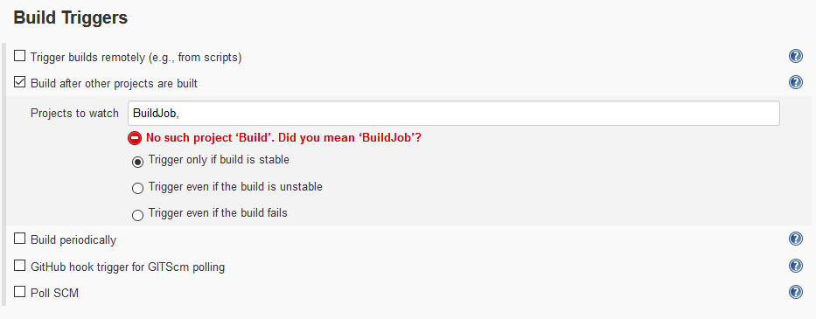

**Creating DeployJob**

1. Click on **New Item** on left side of **Jenkins Dashboard.**

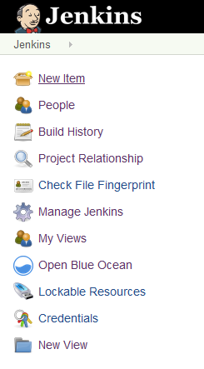

1. Enter Project name as **DeployJob** and select **Freestyle** project as project type. Click on OK.

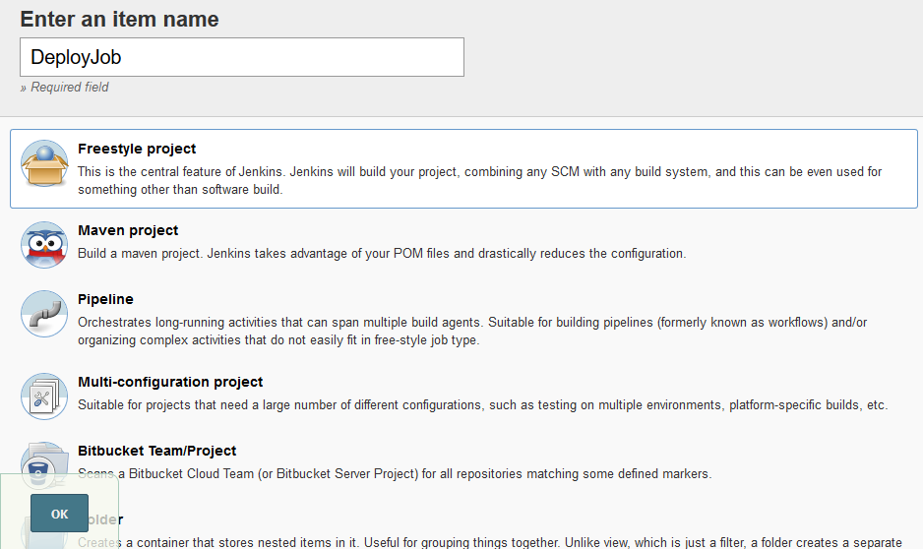

1. In **Configure Job** -> **General** tab => Give description of the job.

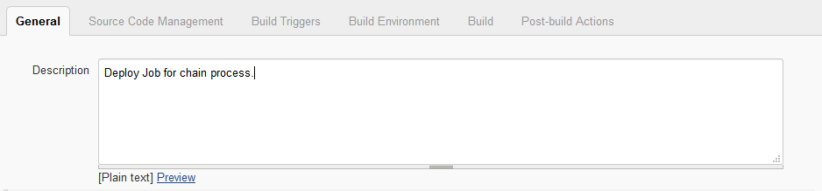

1. In **Configure Job** -> **Build** tab => Add **Execute Windows Batch commands.**

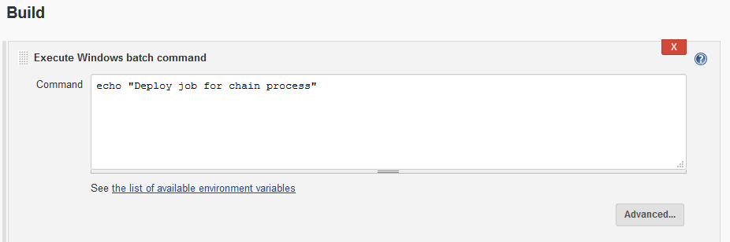

1. In **Configure Job** -> **Build Triggers** tab => Add **after other projects are build** => Specify **TestJob.**

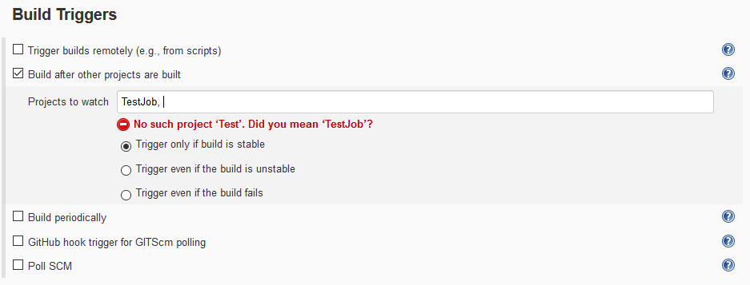

**Building Project “BuildJob” Manually**

Building the BuildJob project will automatically build the other projects in the pipeline using Build Triggers as specified above.

1. Build Job executes and triggers Test Job.

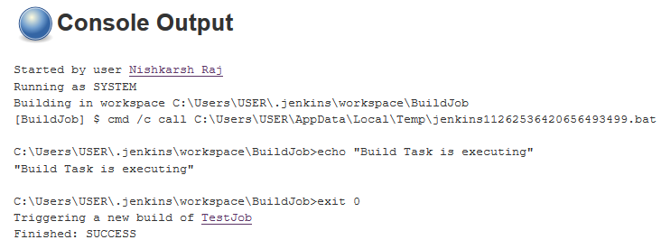

1. Test Job executes and triggers Deploy Job.

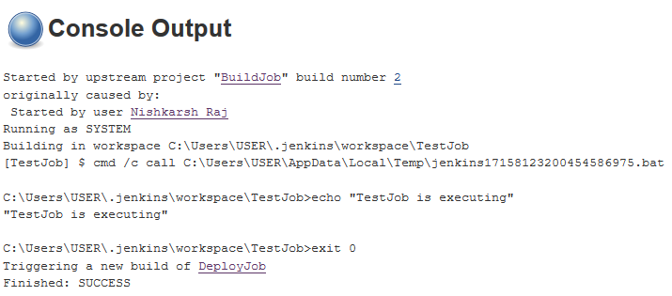

1. Deploy Job executes

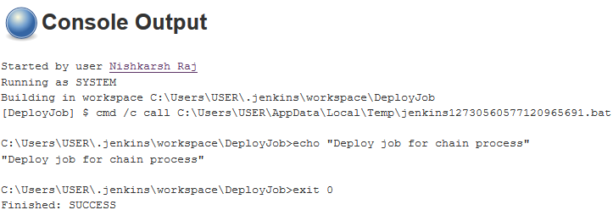

**Creation of Delivery Pipeline View**

**Pre-requisite:** Delivery Pipeline Plugin

**Creation of pipeline:**

1. Click on **New View** on left side of Jenkins Dashboard.

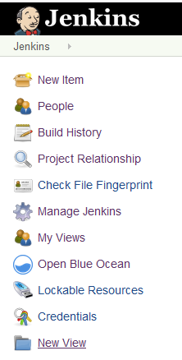

1. Enter **View name** and select **Delivery Pipeline View** from option menu.

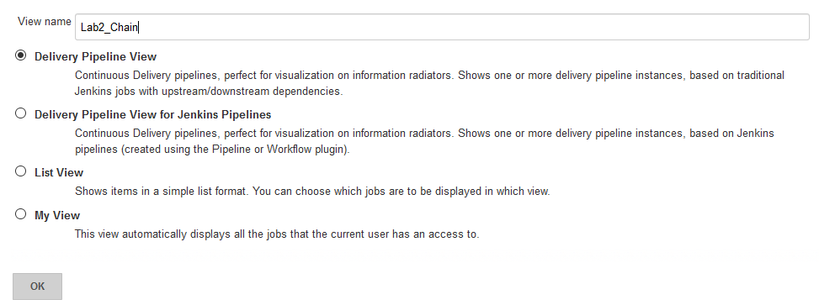

1. In the **configuration settings**, go **to Pipeline** -> Create new **component**
2. Enter component name and enter **BuildJob as initial job**.

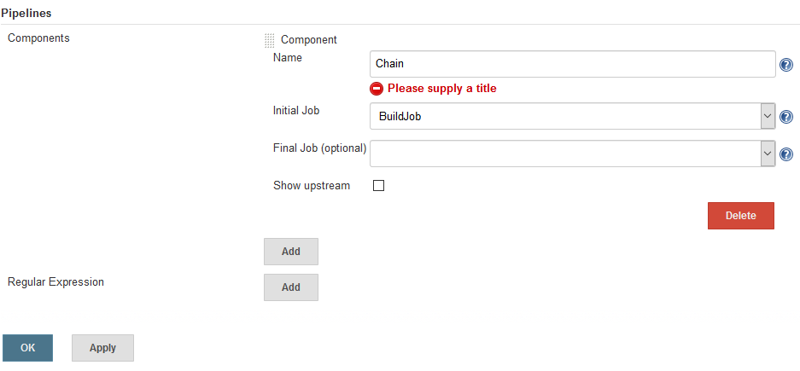

1. Click on Ok.
2. Go to **My views** and select the created view.

